Learning & Teaching Materials on
SOW Motivational Talk Contest –
WRITING A MOTIVATIONAL SPEECH (Secondary Level)

A motivational speech can inspire and persuade others to make a positive change in their lives.
To craft a powerful motivational speech, a well-thought-out plan and careful use of writing techniques can really make a difference.

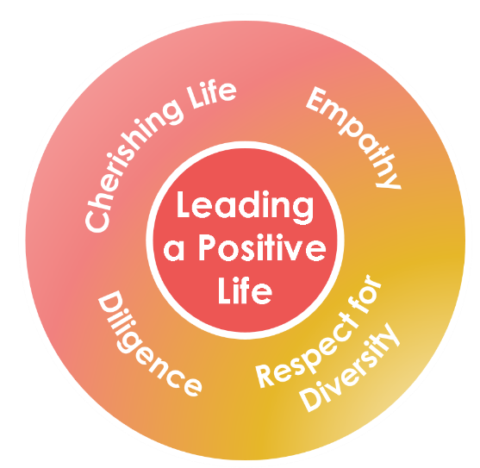

You may use the space below to draw a mind map.

 |  |  | Example A |  |  |  | Example B
Title of text: |  |  | Wonder (the film)  directed by Stephen Chbosky |  |  |  | Positive Corner  written by Robert P. Wright
Theme: (Please ) |  |  | - Diligence | - Cherishing Life |  |  | - Diligence | - Cherishing Life
 |  |  | - Empathy | - Respect for Diversity |  |  | - Empathy | - Respect for Diversity
Saying of Wisdom: |  |  | Be kind, for everyone is fighting a hard battle. |  |  |  | No pain, no gain.
Structure | Focuses |  | Example A |  |  |  | Example B
Opening | - To hook the audience  - To introduce the text  - To state the theme |  | Imagine going to a new environment in which you knew no one and needed to blend in, how’d you feel? Anxious? I’d feel the same way too. It’s almost like leaving the comfort zone we’ve lived in. Yet, it’s worse for August Pullman (Auggie) with his facial deformity in the film by Stephen Chbosky. Blending in was harder than usual for Auggie, but he never ceased to stand his ground with his quiet strength in the face of immense challenges and repeated attacks by classmates. Wonder taught me to ‘be kind, for everyone is fighting a hard battle.’ |  |  |  | Do you sometimes feel discouraged and want to give up when you experience difficulties? I used to but after reading the book Positive Corner by Robert P. Wright, I started to think the opposite and agree with the proverb ‘No pain, no gain!’ Now, I believe that it’s through failure that we become experienced and knowledgeable. It is good to be challenged before we can enjoy the fruits of success.
Body | - To introduce the main plot/theme of the text  - To bring out the key message(s) |  | Wonder is about Auggie’s struggles to get through the fifth grade in Beecher Prep. Despite facing issues such as peer pressure and bullying like everyone else, Auggie always chose to be empathetic to others – to be forgiving, to be understanding and to be kind. Not only did Auggie forgive his best friend, Jack Will, when he bad-mouthed him with the bully, Julian, but he also stood up to a group of bullies and protected Jack Will in a fight. Auggie’s compassion for others had empowered those alike and influenced those who were different. I learnt to put myself in others’ shoes and be compassionate too. |  |  |  | The book offers a lot of tips on living a happy, joyful and positive life with everyday life examples and handy tips. Positive Corner guides me to get through difficulties and challenges, and gives me a positive direction in life. In one of the stories, the writer uses the quote “A winner never quits and a quitter never wins!” and it evokes memories of my running training. Many a time in my training, I was frustrated by not making any progress. I felt stuck and even thought of giving up. Thanks to my coach’s constant encouragement, I persisted. Now I understand that even though I am working really hard, the gains may be slow. It’s easy to quit, but if I quit, I get nothing.
Ending | - To recap the key message(s)  - To inspire reflection  - To call to action |  | I hope it won’t take forever for us to realise that empathy is a superpower, a superpower that saves suffering souls, heals hopeless hearts and forges a fruitful future. Let’s break the bubble we’ve lived in and take one step further to empathise with others when we are all in the same boat. |  |  |  | Our journey in life is like a marathon. We need to put in a lot of efforts to strengthen our body and mind, to persist with determination, to battle with obstacles, or else we are destined to fail. “No pain, no gain!” There is no shortcut to success.  Let’s all get our heads down and strive to reach our goal!

Curriculum Development Institute
Education Bureau HKSAR ©2022

Title of text:
Theme: (Please ) |  |  | - Diligence | - Cherishing Life
 |  |  | - Empathy | - Respect for Diversity
Saying of Wisdom:
Structure | Focuses |  | Your turn
Opening | - To hook the audience  - To introduce the text  - To state the theme
Body | - To introduce the main plot/theme of the text  - To bring out the key message(s)
Ending | - To recap the key message(s)  - To inspire reflection  - To call to action

After coming up with what to tell, you may need to think about how to express your ideas. Some writing techniques and rhetorical devices to make your speech more engaging and powerful.
Identity the rhetorical devices used in the sample paragraphs on P.2 and put them in the table below. Polish your ideas with the rhetorical devices in the spaces provided.
Writing Techniques | Rhetorical devices | Purposes | Example A | Example B | Your Turn
Comparison | Simile | A simile or a metaphor can create an image that helps the audience understand and stick in their minds.
 | Metaphor
Repetition | Alliteration | Repetition of the initial letter sound helps catch audience’s attention and create a rhythm and mood.
 | Parallelism | Repeating of phrases and language structure makes the message more powerful and enhances the rhythm.

